1st Grade Weekly Newsletter
Week of April 13-17

Teacher Contact Information:
1-01 Ms. Washington - washingtoncb1@scsk12.org 1-03 Ms. Castellano - castellanom@scsk12.org
1-02 Ms. Higginbotham - sagere@scsk12.org 1-04 Ms. Webster - websterl@scsk12.org

** Please complete the BLUE iReady lessons first**

Weekly Journal Prompt: Talk about a day at the park. What did you see?

1st Grade | Monday
Math: Build Teen Numbers  Access I-Ready through Edugoodies  (Click here to access Edugoodies.com) | ELA: Say Beginning Digraphs and Consonant Blends  Access I-Ready through Edugoodies  (Click here to access Edugoodies.com)
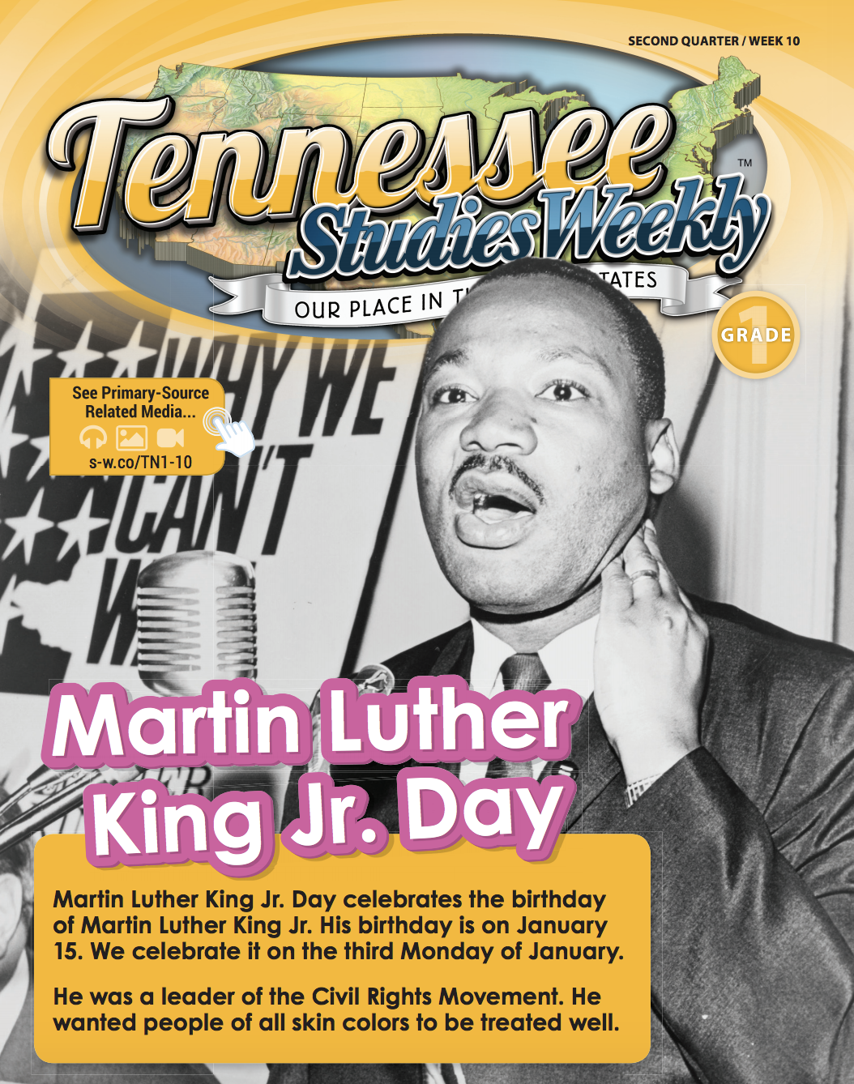  Social Studies:  Martin Luther King Jr. Day  Access through Clever. Once you finish reading, go take the assessment online. | 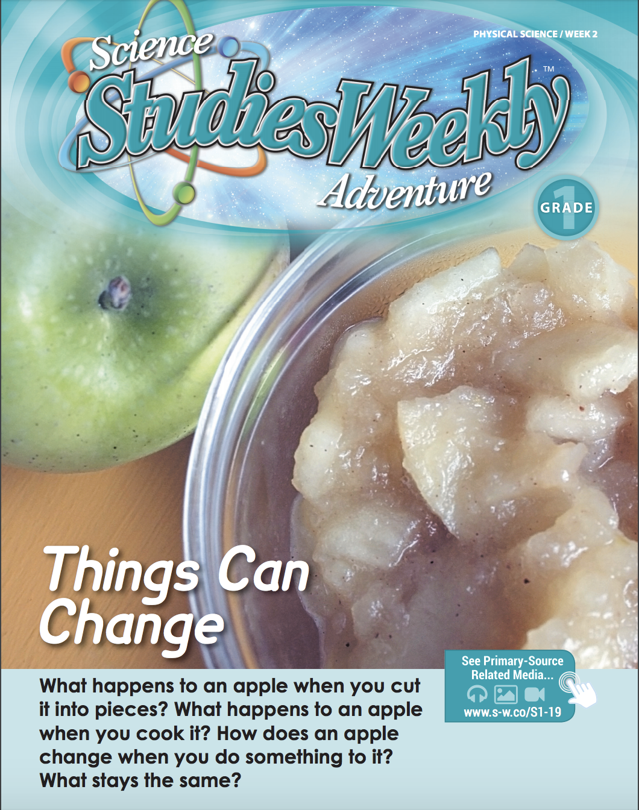  Science:  Things Can Change  Access through Clever. Once you finish reading, go take the assessment online
1st Grade | Tuesday
Math: Practice: Build Teen Numbers  Access I-Ready through Edugoodies  (Click here to access Edugoodies.com) | ELA: Say Final Digraph and Consonant Blends  Access I-Ready through Edugoodies  (Click here to access Edugoodies.com)
1st Grade | Wednesday
Math: Identify Two-Digit Numbers  Access I-Ready through Edugoodies  (Click here to access Edugoodies.com) | ELA: Compare Short and Long Vowel Sounds  Access I-Ready through Edugoodies  (Click here to access Edugoodies.com)
1st Grade | Thursday
Math: Practice: Identify Two-Digit Numbers  Access I-Ready through Edugoodies  (Click here to access Edugoodies.com) | ELA: Blend Words with Beginning Digraphs  Access I-Ready through Edugoodies  (Click here to access Edugoodies.com)
1st Grade | Friday
Math: Build Two-Digit Numbers  Access I-Ready through Edugoodies  (Click here to access Edugoodies.com) | ELA: Say Short and Long Vowels Sounds in Words  Access I-Ready through Edugoodies  (Click here to access Edugoodies.com)

